Contents

Open Close File 1600 w 2

Open Close File 1600 w 3

Open Close File 1600 w CPU Profiling 4

Open Close File 1600 w Memory Profiling 5

State Machine 102400 CPU Profiling 6

State Machine 204800 Memory Profiling 7

Hot Spot Methods 9

Open Close File 6400 w HEAP 10

# Open Close File 1600 w

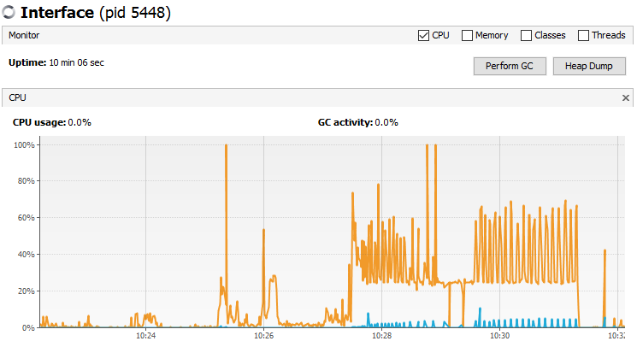

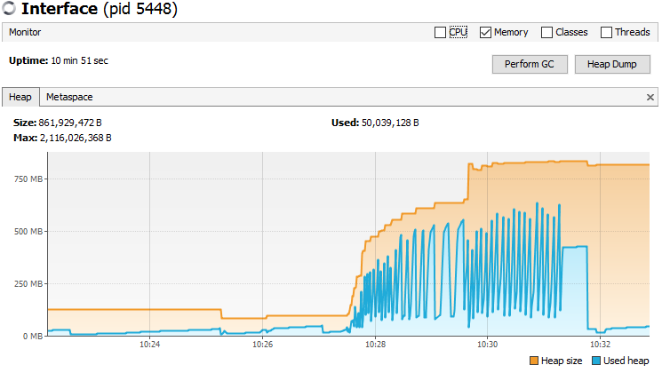

# Open Close File 1600 w

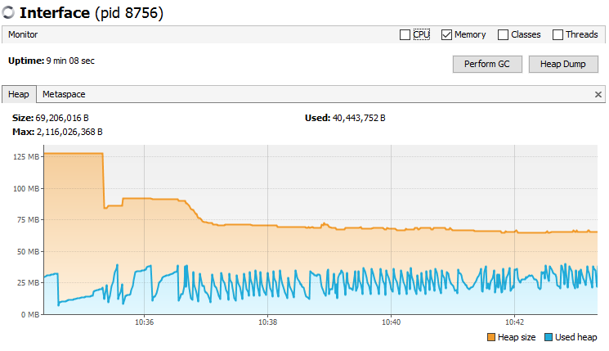

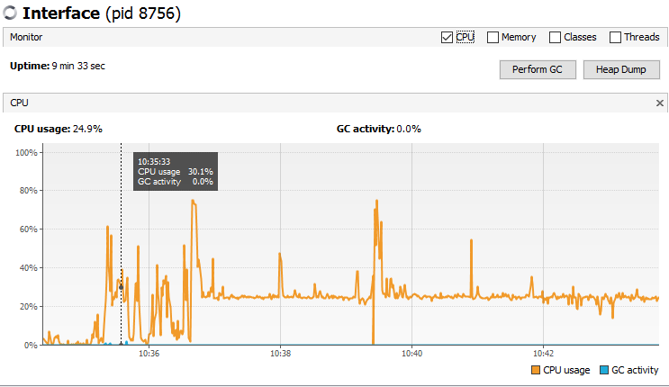

# Open Close File 1600 w CPU Profiling

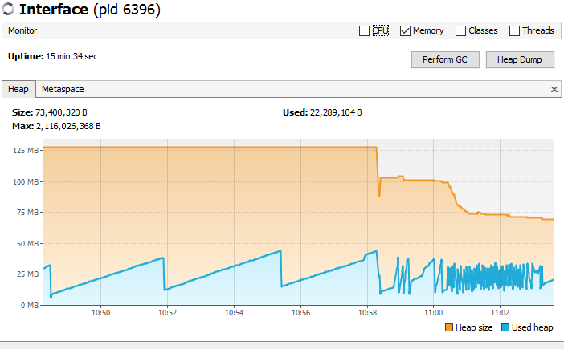

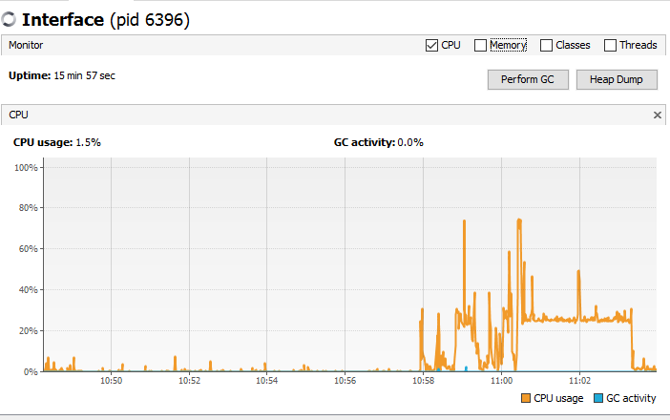



# Open Close File 1600 w Memory Profiling

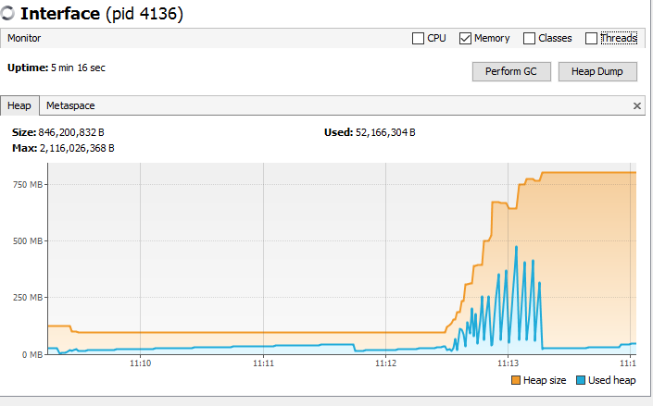

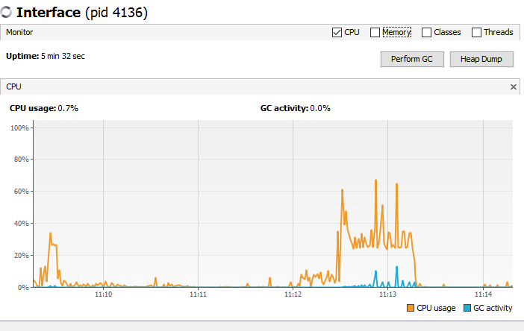



# State Machine 102400 CPU Profiling

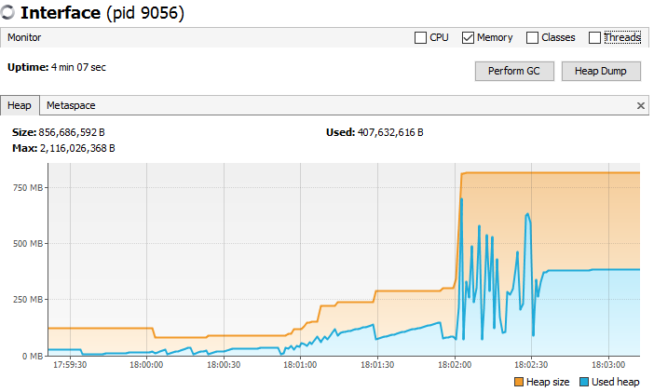

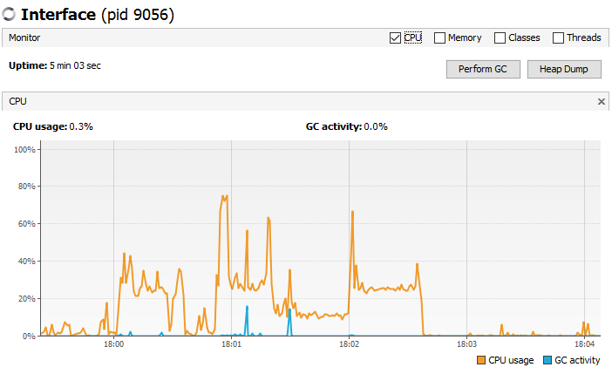



# State Machine 204800 Memory Profiling

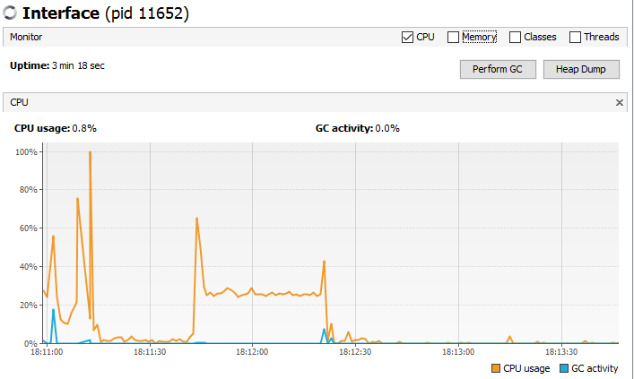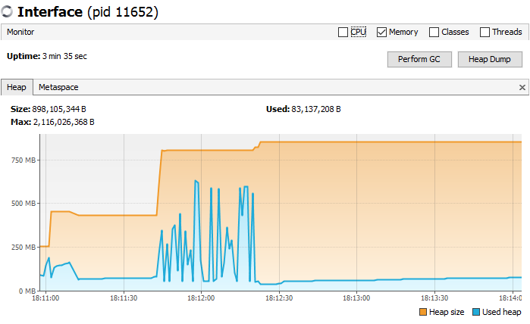



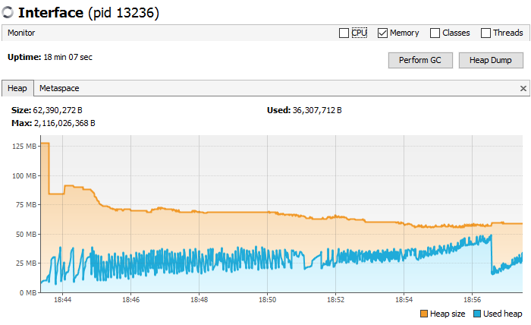

# Hot Spot Methods

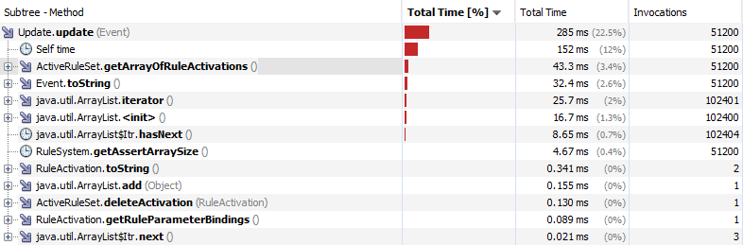

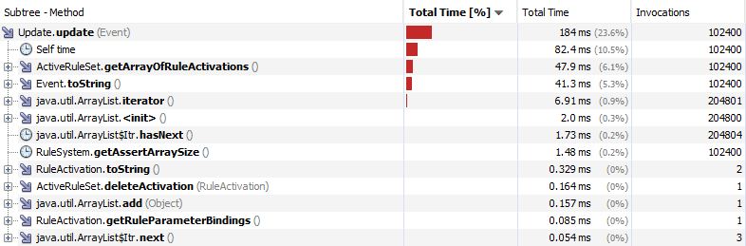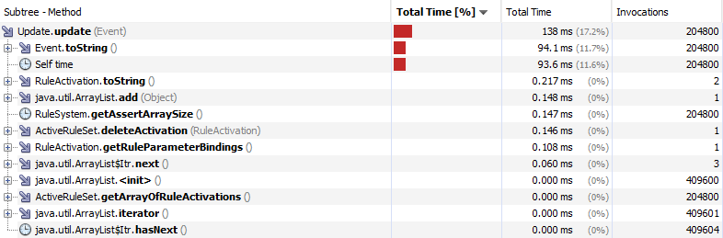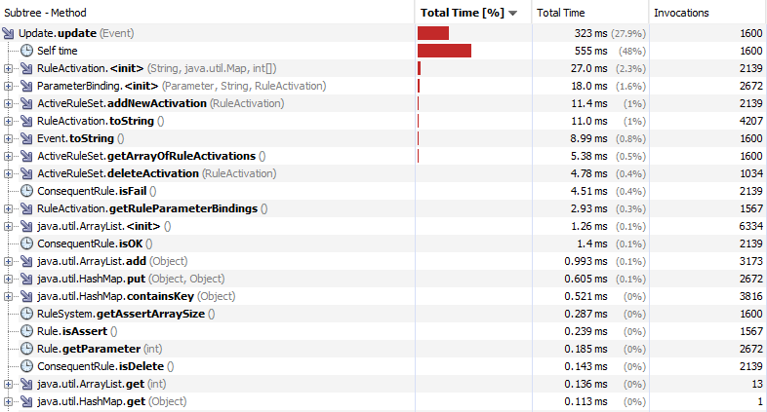

# Open Close File 6400 w HEAP

